**КИЇВСЬКИЙ ФАХОВИЙ КОЛЕДЖ ЗВ’ЯЗКУ**

**WORK-CASE №3**

з дисципліни «Операційні системи»

Виконали: студенти **3** курсу, групи **КСМ-13А**

**Засенко Олександр**

(прізвище та ініціали)

**Дзюбенко Дмитро**

(прізвище та ініціали)

**Сторожук Костянтин**

(прізвище та ініціали)

Київ  2023

**ЗМІСТ**

Clone a virtual machine in Oracle VirtualBox …………………………………...……..3

Exporting a virtual machine from Oracle VirtualBox………………………..………….5

Types of network connection organization………………………………………………7

Organization of information exchange between OS versions……………………………9

Conclusions.……………………………………………………………………………..11

**The material was prepared by a student Zasenko**

**Cloning a virtual machine in Oracle VirtualBox**

Cloning a virtual machine in Oracle VirtualBox is a simple process and can be useful if you need to create multiple identical virtual machines. Here are the steps to clone a virtual machine:

1. Open Oracle VirtualBox: Start the Oracle VirtualBox program on your computer.

2. Select the virtual machine to clone: In the VirtualBox window, select the virtual machine you want to clone from the list of virtual machines.

3. Copy the virtual machine: Right-click on the selected virtual machine and select the "Clone" or "Clone VM" option, depending on the version of VirtualBox you are using.

4. Configure the cloning settings: You will see the "Clone Virtual Machine" window where you can specify the settings for the new cloned virtual machine. This includes a new name, a folder where the clone will be saved, and other options as desired.

5. Start cloning: After configuring the settings, click Clone to start the cloning process.

6. Start the new cloned virtual machine: After the cloning is complete, you can select the new cloned virtual machine in the virtual machine list and start it.

You now have a cloned copy of your virtual machine that you can configure and use without affecting the original machine.

**The material was prepared by a student Dzubenko**

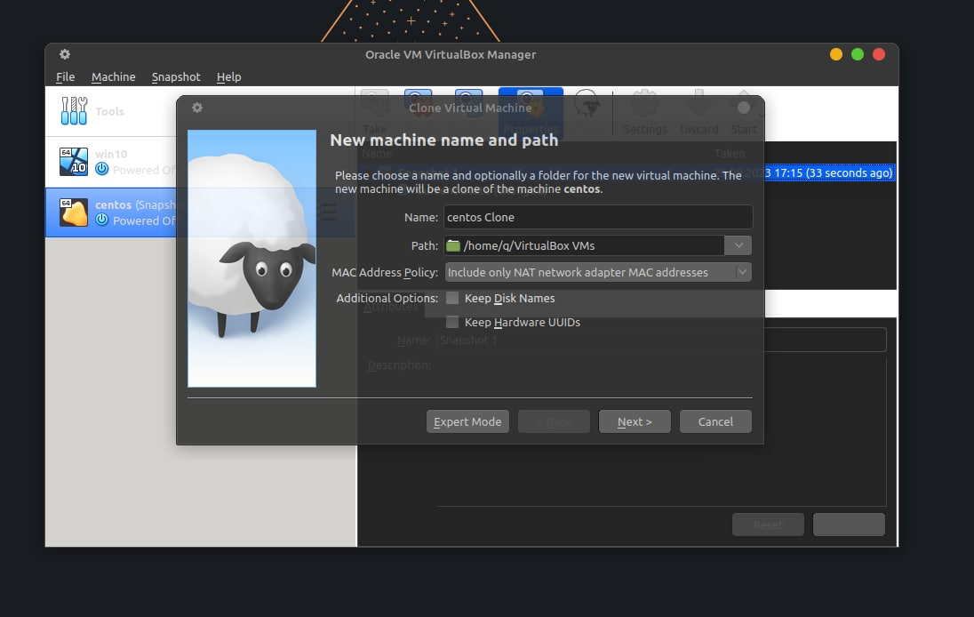

Fig. 1 Cloning a machine

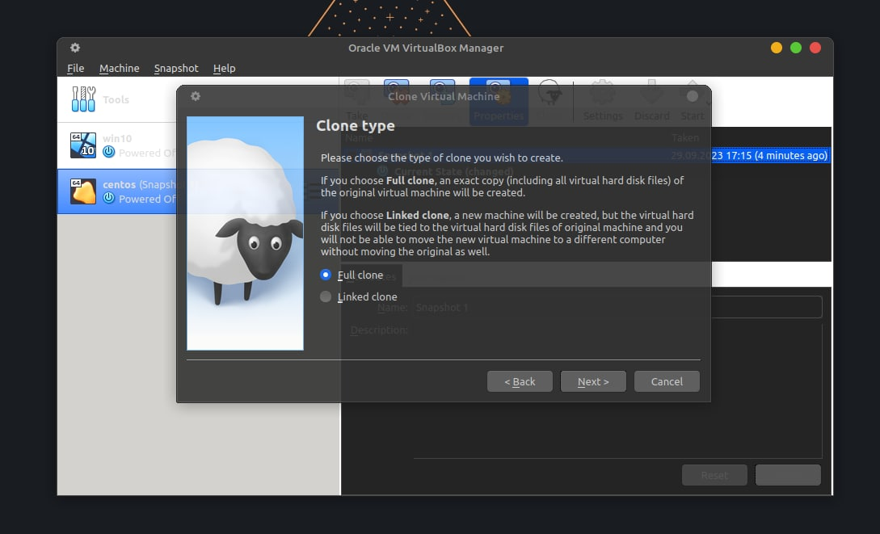

Fig. 2 Selecting a clone

**The material was prepared by a student Zasenko**

**Export a virtual machine from Oracle VirtualBox**

To export a virtual machine from Oracle VirtualBox, follow these steps:

1.Start Oracle VirtualBox: Open the Oracle VirtualBox program on your computer.

2. Select the virtual machine to export: In the VirtualBox window, select the virtual machine you want to export from the list of virtual machines.

3. Stop the virtual machine: Make sure the virtual machine is stopped (turned off). You cannot export a virtual machine that is currently running.

4. Select the export option: Right-click on the selected virtual machine and select the "Export Appliance" or "Export" option, depending on the version of VirtualBox you are using.

5. Configure the export settings: The Export Wizard opens, where you can configure the options for exporting the virtual machine. This includes choosing a location to save the exported image, selecting a format (usually the OVA format is used), and the ability to include or exclude data volumes.

6. Start the export: After configuring the export options, click the Export or Next button to start the export process.

7. Complete the export: When the export is complete, an image file (usually with the .ova extension) will be created that contains the virtual machine and all its settings.

You now have an image file of your virtual machine that can be imported into another instance of Oracle VirtualBox or another virtualization platform for further use.

**The material was prepared by a student Dzubenko**

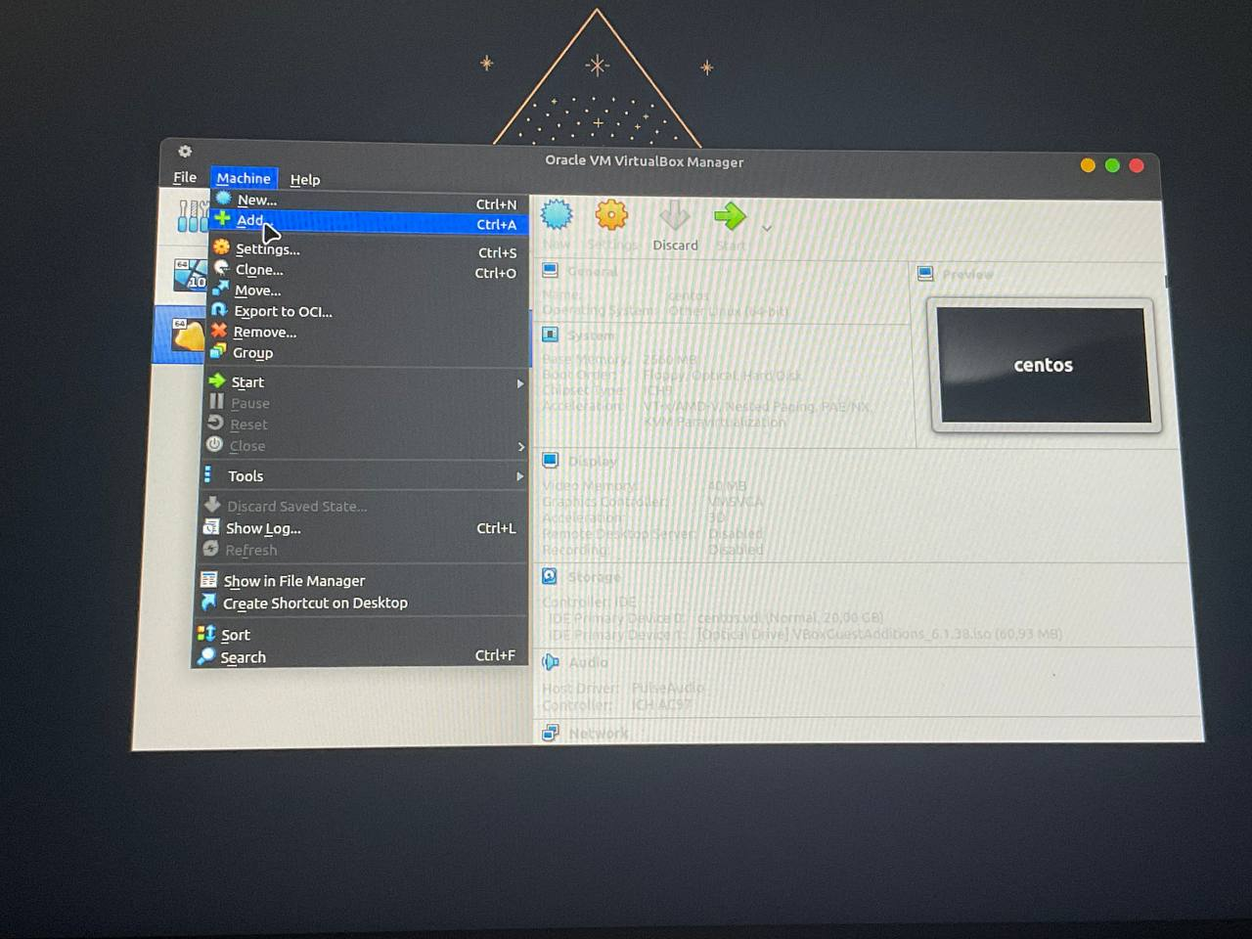

Fig. 3 Adding a clone

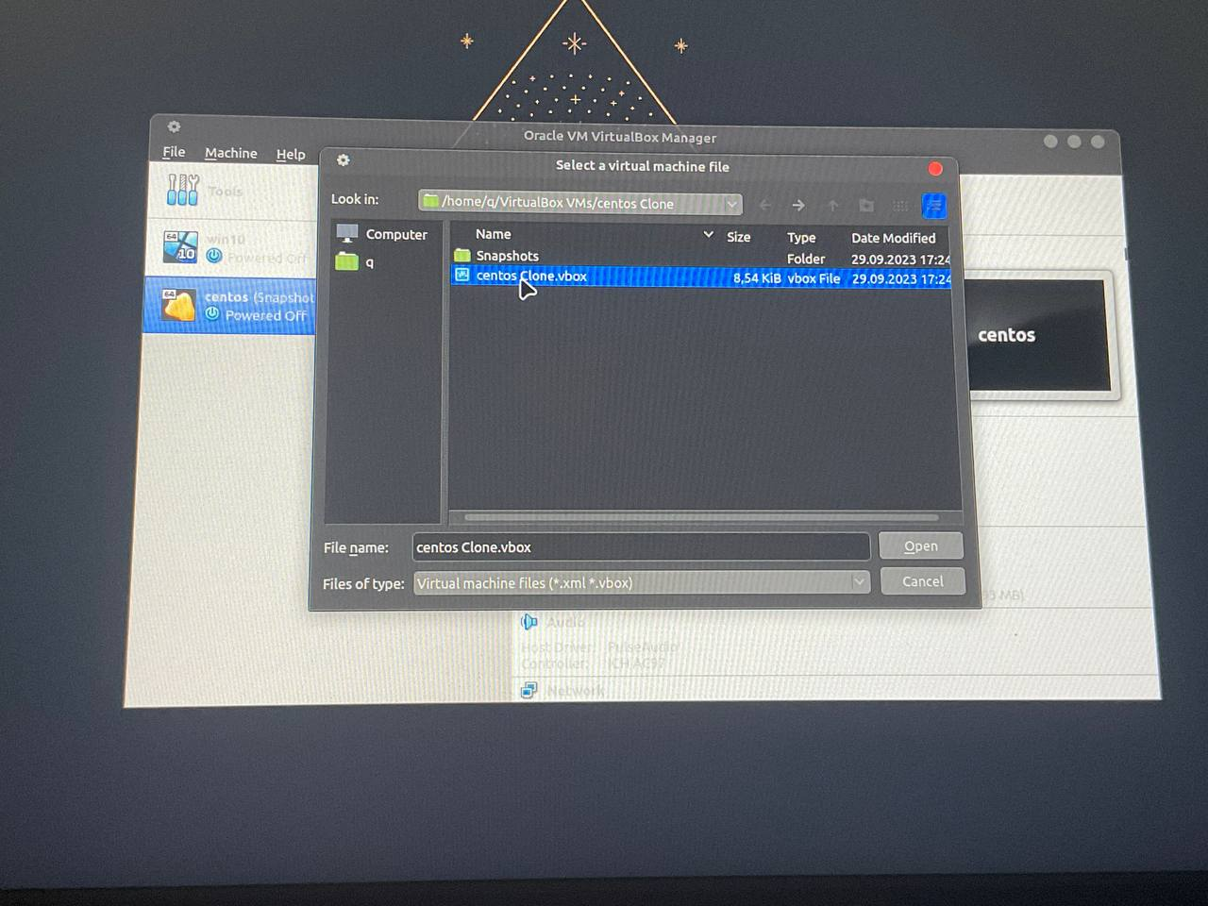

Fig. 4 Choosing a clone

To clone a virtual machine, it is possible to use a system partition with a move, but it does not always work correctly. To move the OS, I will use the following steps, namely: 1. Remove the virtual OS from the list of all machines (from the list, not all files). 2. After uninstalling, find the VirtualBox VMs folder (in my case, you may have a different folder name), open a copy of your virtual OS and then you can safely move the folder with the copy of the OS between computers and on flash drives. 3. To restore the virtual system, we need to select -> Machine -> Add -> and select the location of your folder in which the folder with the copy of the system is located in the drop-down menu. 4. After finding the folder, open it and select the file with a mark at the end of .vbox. 5. After adding the file, you can safely use the virtual machine you migrated.

**The material was prepared by a student Zasenko**

**Types of network connections organization**

In a virtual machine environment such as Oracle VirtualBox, different types of networking arrangements are supported, which provide different levels of control and provide different opportunities for interaction between virtual machines and the external network environment. Here is a detailed description of each of them:

1. Network Address Translation (NAT):

- Feature: In NAT mode, the virtual machine has access to the network, but all network traffic from the virtual machine will go through a host system that uses address translation. This means that external systems cannot directly establish connections to the virtual machine, but it can initiate connections to other systems on the external network. This mode is useful for providing access to a virtual machine on the Internet or an external network.

2. Network Bridge (Bridged):

- Feature: In network bridge mode, the virtual machine connects to a real network like any physical computer. It gets its own IP address from the network and can communicate with other systems on the network as if it were a separate physical computer. This mode allows virtual machines to become part of a real network and provides full interaction with other systems on that network.

3. Host-only virtual adapter:

- Feature: In virtual host adapter mode, virtual machines can only communicate with each other and with the host system. This network is separated from the external network, and the virtual machines have their own internal network that is not connected to the real network. It is useful for creating virtual test environments or for providing internal communication between virtual machines and the host system.

4. Internal Network:

- Feature: In Internal Network mode, virtual machines connect to an isolated internal network, and they can only communicate with each other, but do not have access to an external network or the Internet. This mode is useful when you want to create a separate virtual environment for virtual machines to interact, but separate from the external network.

The type of network organization you choose depends on the specific needs and requirements of your virtual environment. You can use different types for different tasks or combine them to create more complex network configurations.

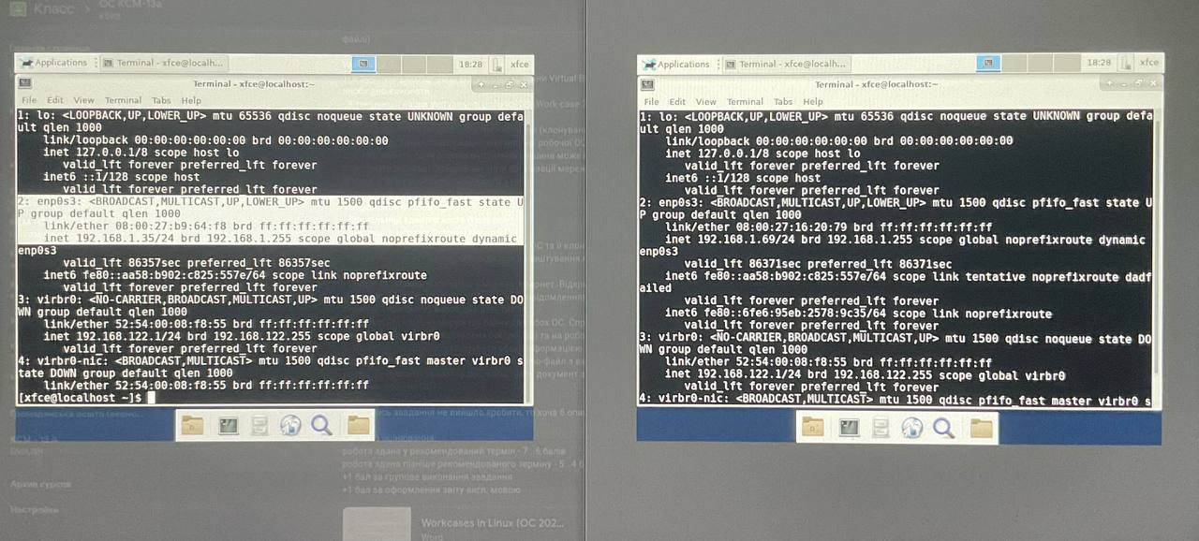

Fig. 5 Connecting to a single local network

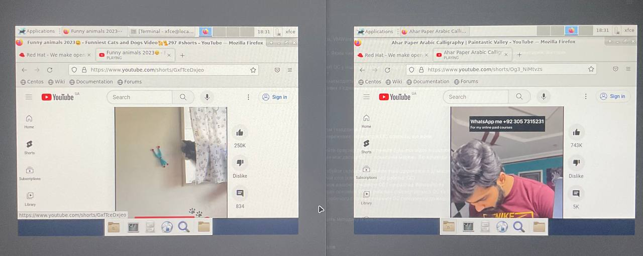

Fig. 6: Single watching YouTube

**The material was prepared by a student Zasenko**

**Organize the exchange of information between your main windows OS and virtual OSes**

There are various ways and technologies to organize the exchange of information between your main Windows operating system and the virtual operating systems you use in virtual machines. Here are some of them:

1. Using Shared Folders:

- Many virtual machine programs, including Oracle VirtualBox and VMware Workstation, provide the ability to set up "Shared Folders" between the virtual machine and the host operating system. This allows you to easily share files between them.

2. Using network resources:

- Establish a network connection between the virtual machine and the host OS, and then use network file and resource sharing such as SMB (Windows File Sharing) or NFS (Network File System).

3. Use FTP or SCP:

- You can install an FTP server or SCP (Secure Copy Protocol) on the virtual machine and use an FTP client or SCP client on the host OS to copy files between them.

4. Use cloud services:

- You can upload files to a cloud storage service such as Dropbox, Google Drive, or OneDrive from your host OS and then access them from the virtual machine or vice versa.

5. Using Email or instant messengers:

- You can send files via email or instant messengers like Skype or Slack and open them on the virtual machine.

6. Upload files through a web browser:

- You can download files to or from your virtual machine through a web browser using the appropriate web services or web interfaces for managing your virtual machine.

The specific method you choose depends on your needs and the settings of the virtual machine you are using. Most of these methods allow for efficient communication between your main operating system and virtual machines.

**Conclusions**

During this work, we learned how to clone operating systems, export them, set up a local network between them, and transfer files between these operating systems. We encountered one problem, which was an error in the system section of the move, but we found information on how to do it differently and described the action plan in the section "Cloning an operating system". We were working on the work: Dziubenko - working with virtualbox, Zasenko - searching for information in Ukrainian, Storozhuk - translating the text and editing the file.